**35 занятий для успешной подготовки к школе. Математика.**

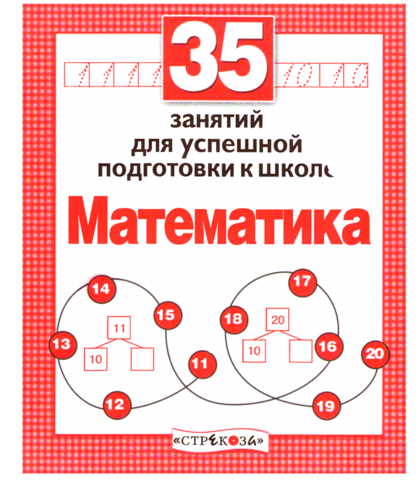

[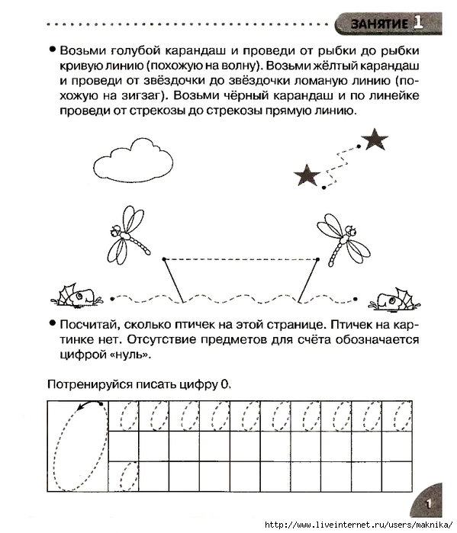](https://img0.liveinternet.ru/images/attach/c/5/89/73/89073978_large_p0002.jpg)  
  
  
[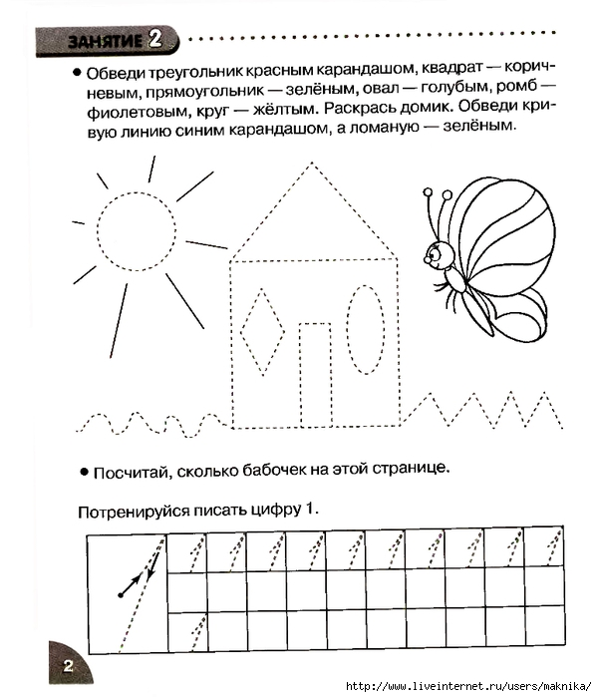](https://img1.liveinternet.ru/images/attach/c/5/89/73/89073981_large_p0003.jpg)  
  
  
[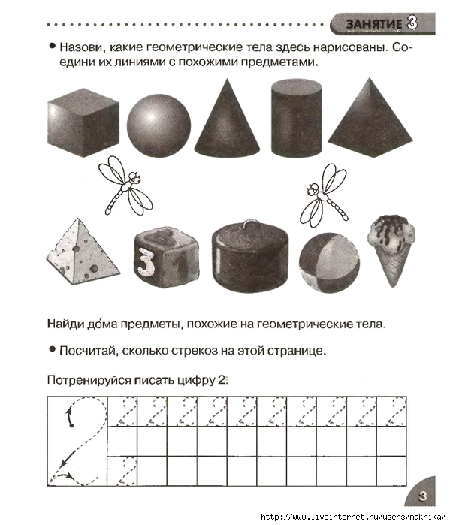](https://img0.liveinternet.ru/images/attach/c/5/89/73/89073984_large_p0004.jpg)  
  
[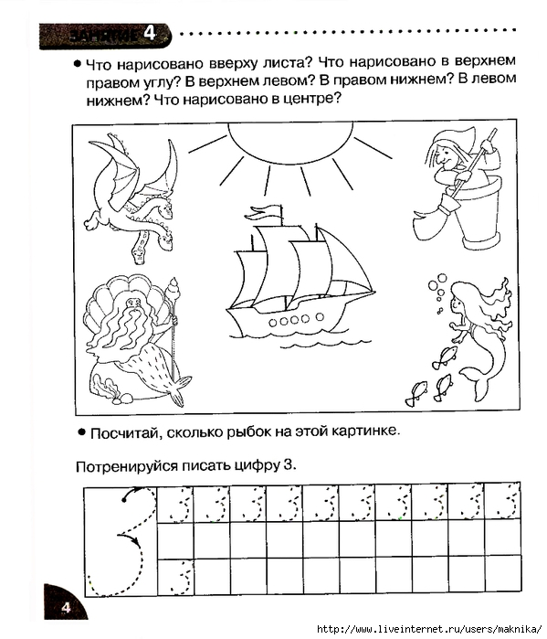](https://img1.liveinternet.ru/images/attach/c/5/89/73/89073989_large_p0005.jpg)  
  
[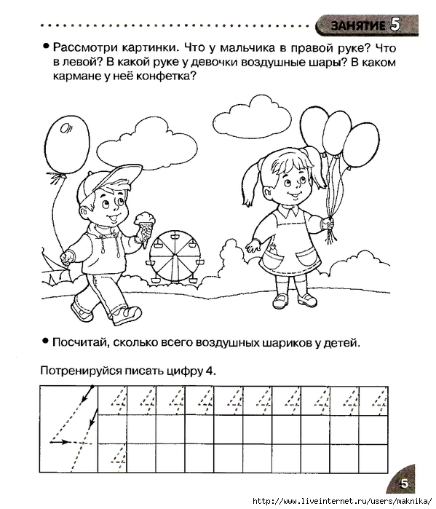](https://img0.liveinternet.ru/images/attach/c/5/89/73/89073998_large_p0006.jpg)  
  
[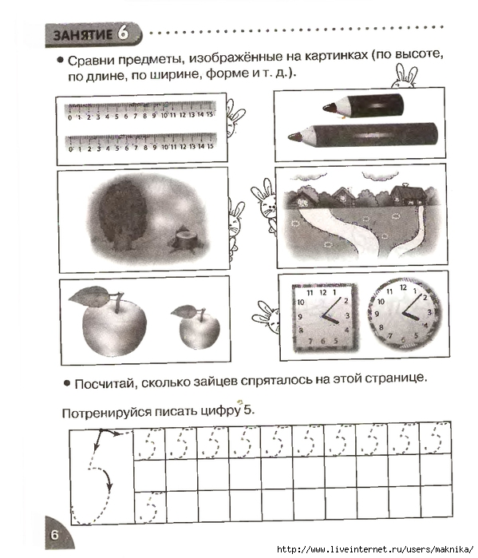](https://img0.liveinternet.ru/images/attach/c/5/89/74/89074002_large_p0007.jpg)  
  
  
[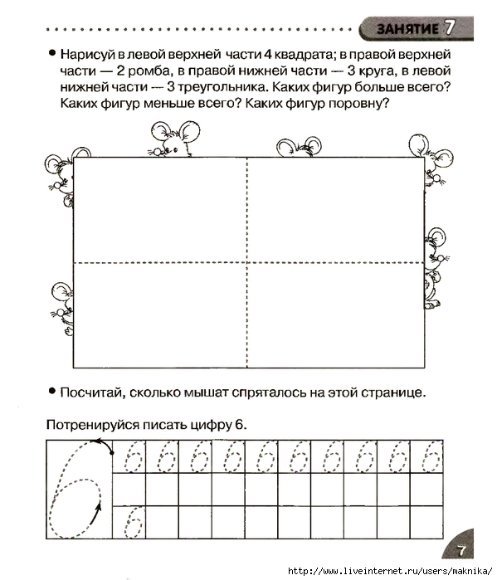](https://img0.liveinternet.ru/images/attach/c/5/89/74/89074006_large_p0008.jpg)  
  
  
[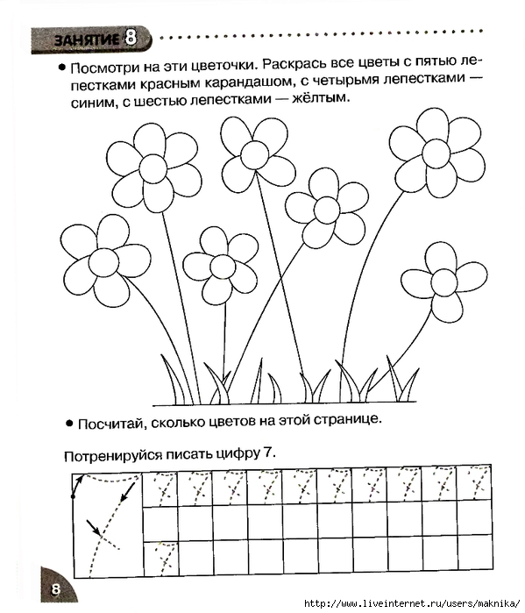](https://img0.liveinternet.ru/images/attach/c/5/89/74/89074008_large_p0009.jpg)  
  
  
[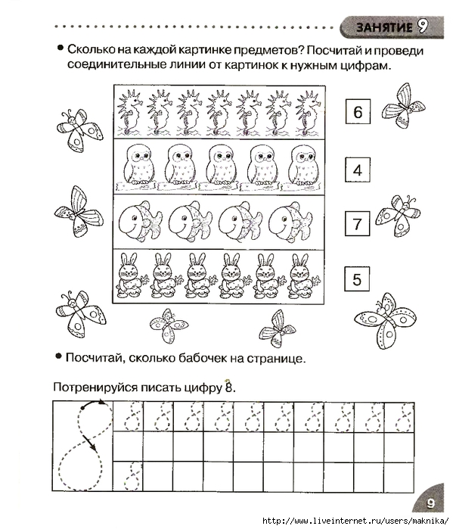](https://img0.liveinternet.ru/images/attach/c/5/89/74/89074010_large_p0010.jpg)  
  
  
[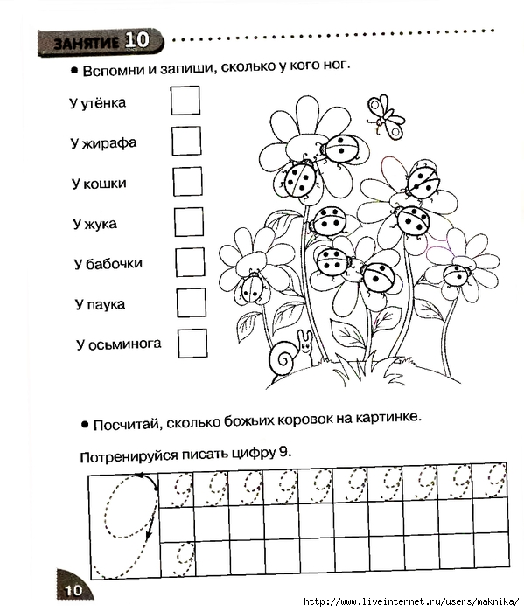](https://img1.liveinternet.ru/images/attach/c/5/89/74/89074013_large_p0011.jpg)  
  
  
[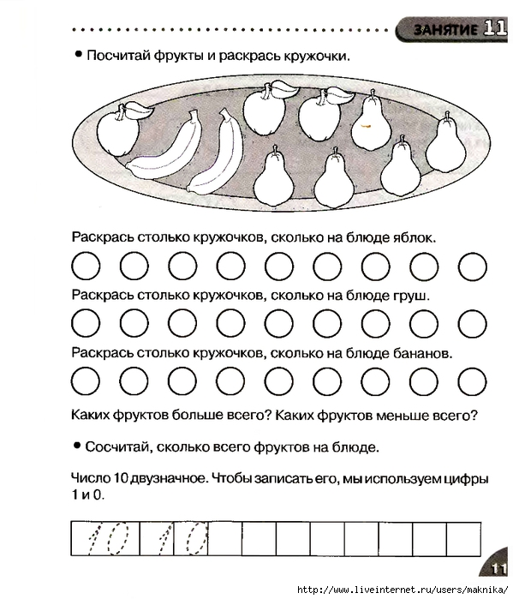](https://img1.liveinternet.ru/images/attach/c/5/89/74/89074015_large_p0012.jpg)  
  
  
[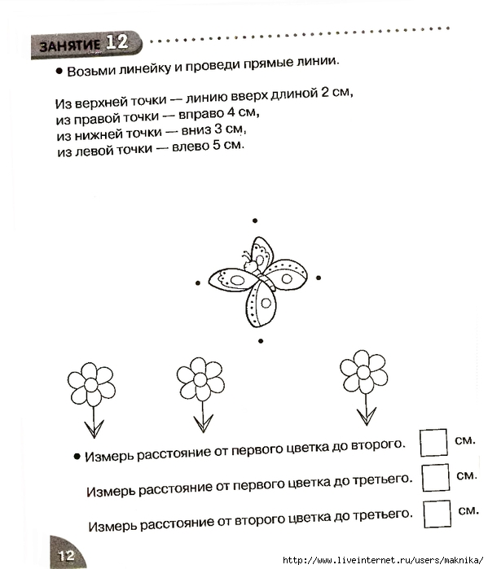](https://img0.liveinternet.ru/images/attach/c/5/89/74/89074018_large_p0013.jpg)  
  
[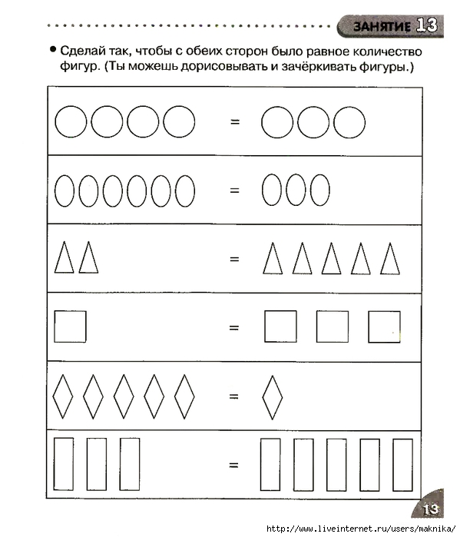](https://img1.liveinternet.ru/images/attach/c/5/89/74/89074021_large_p0014.jpg)  
  
  
[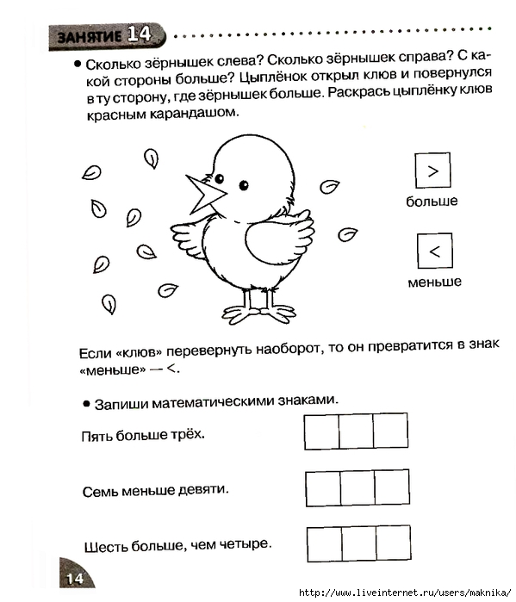](https://img1.liveinternet.ru/images/attach/c/5/89/74/89074023_large_p0015.jpg)  
  
  
[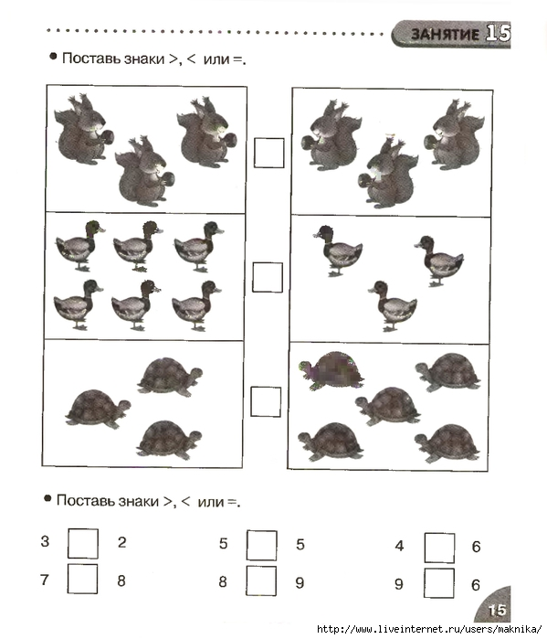](https://img0.liveinternet.ru/images/attach/c/5/89/74/89074026_large_p0016.jpg)  
  
[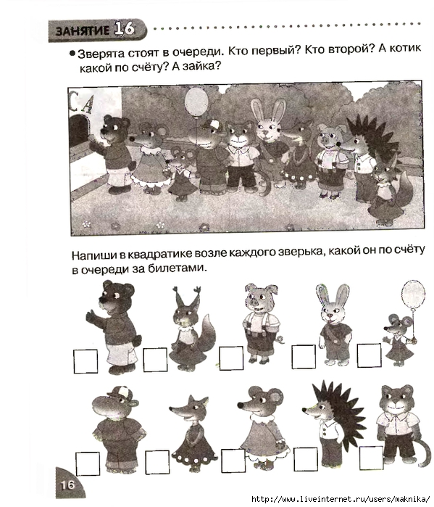](https://img0.liveinternet.ru/images/attach/c/5/89/74/89074028_large_p0017.jpg)  
  
  
[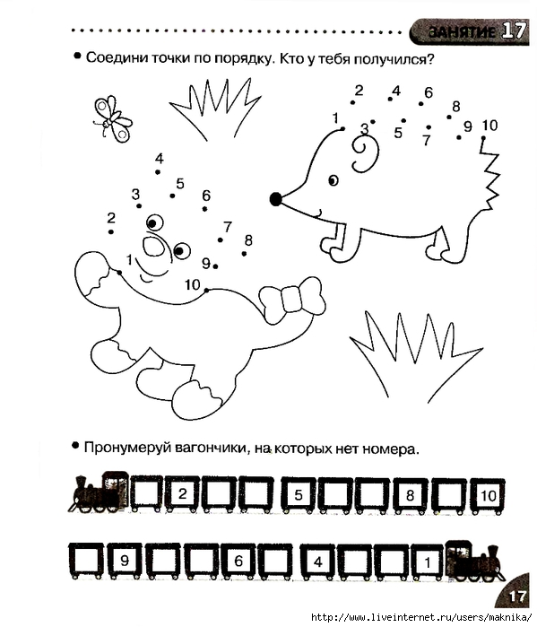](https://img1.liveinternet.ru/images/attach/c/5/89/74/89074031_large_p0018.jpg)  
  
  
[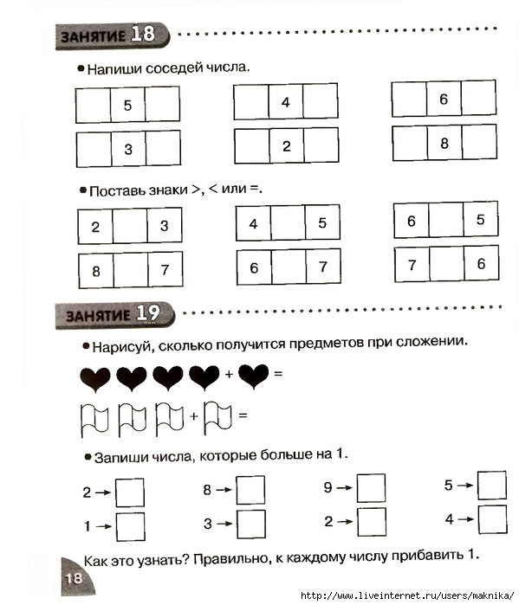](https://img0.liveinternet.ru/images/attach/c/5/89/74/89074034_large_p0019.jpg)  
  
  
[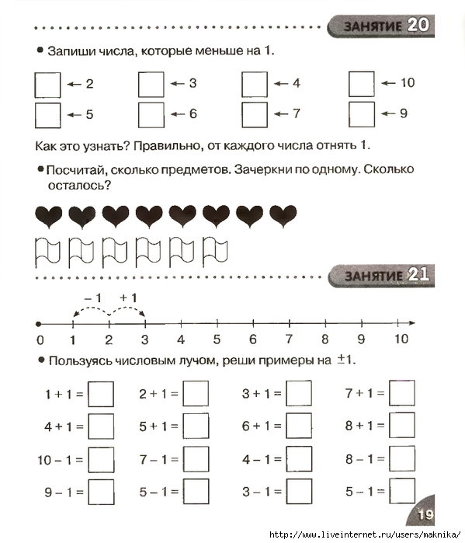](https://img0.liveinternet.ru/images/attach/c/5/89/74/89074036_large_p0020.jpg)  
  
[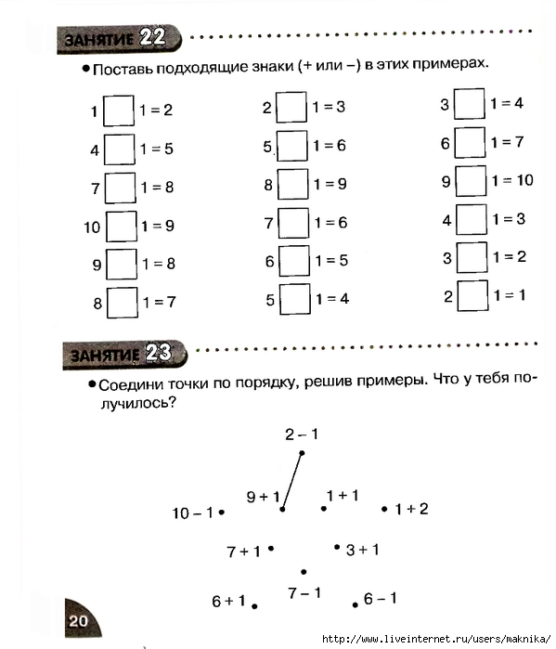](https://img0.liveinternet.ru/images/attach/c/5/89/74/89074038_large_p0021.jpg)  
  
  
[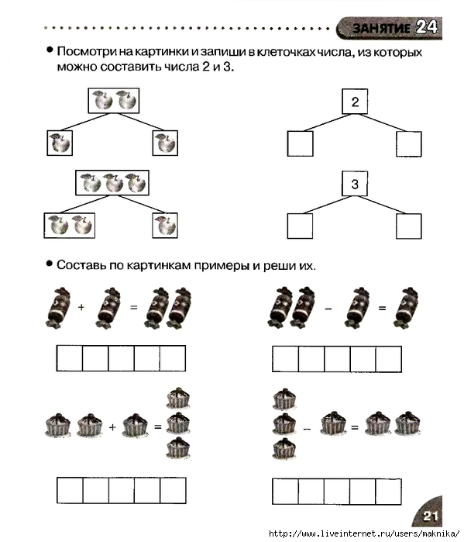](https://img0.liveinternet.ru/images/attach/c/5/89/74/89074042_large_p0022.jpg)  
  
  
[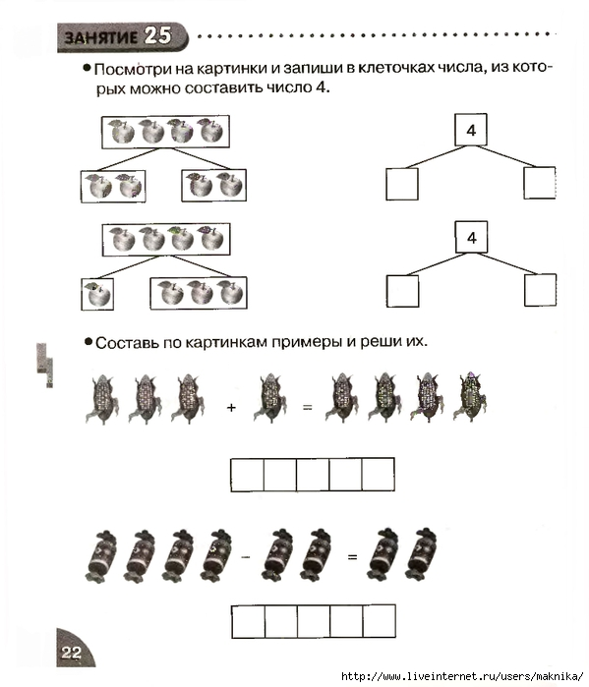](https://img0.liveinternet.ru/images/attach/c/5/89/74/89074044_large_p0023.jpg)  
  
  
[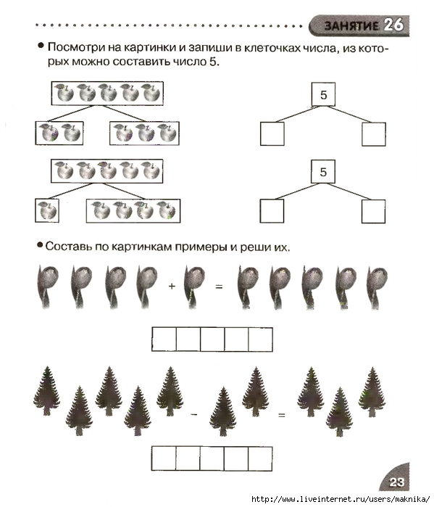](https://img0.liveinternet.ru/images/attach/c/5/89/74/89074048_large_p0024.jpg)  
  
  
[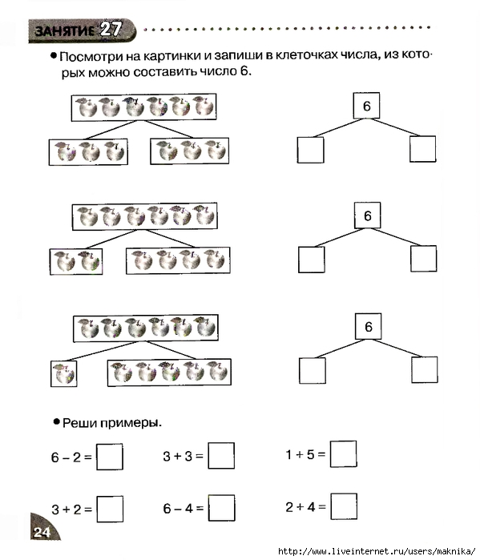](https://img0.liveinternet.ru/images/attach/c/5/89/74/89074050_large_p0025.jpg)

[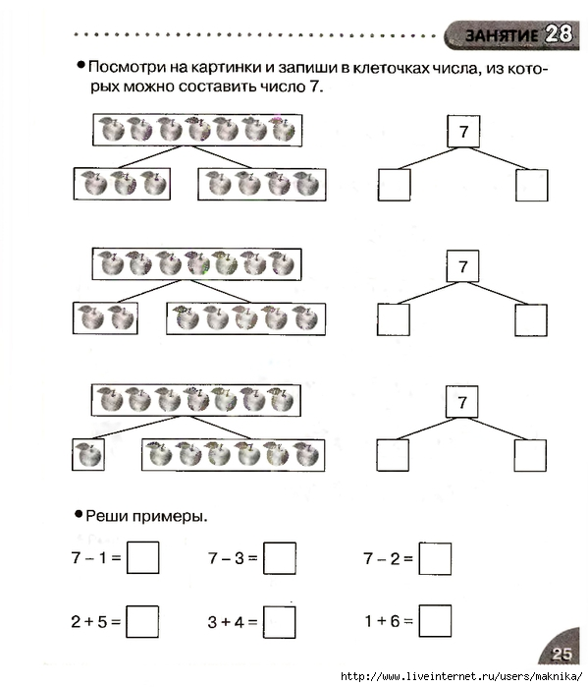](https://img1.liveinternet.ru/images/attach/c/5/89/74/89074139_large_p0026.jpg)  
  
  
[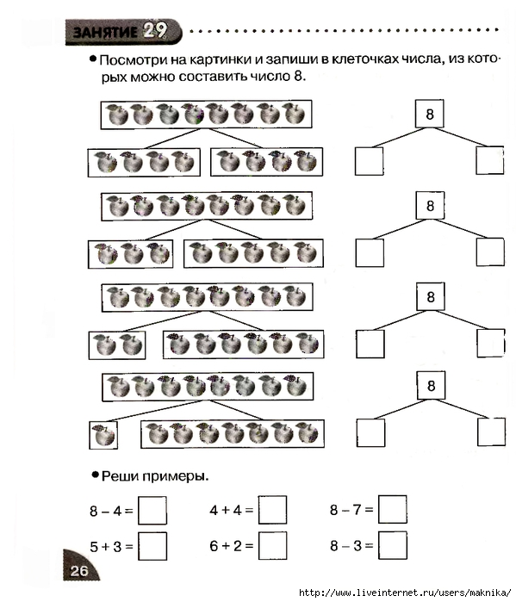](https://img0.liveinternet.ru/images/attach/c/5/89/74/89074140_large_p0027.jpg)  
  
  
[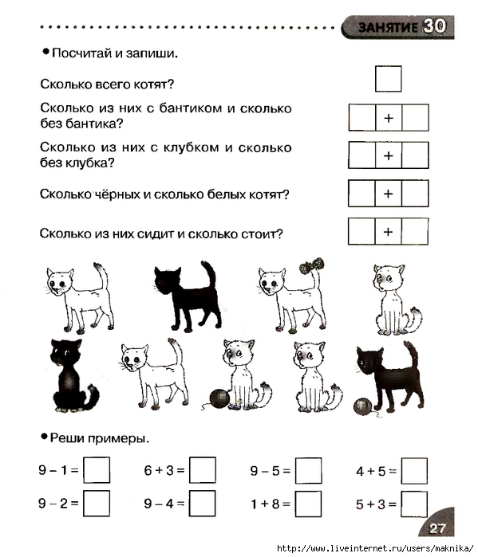](https://img1.liveinternet.ru/images/attach/c/5/89/74/89074141_large_p0028.jpg)  
  
  
[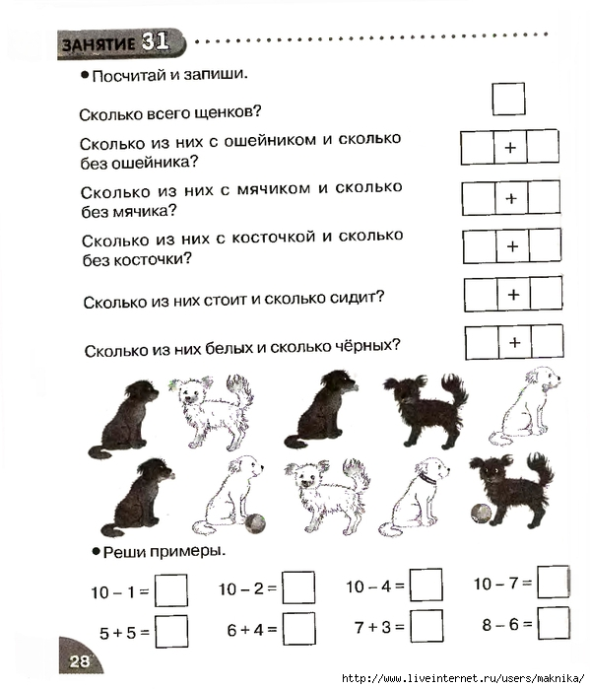](https://img0.liveinternet.ru/images/attach/c/5/89/74/89074142_large_p0029.jpg)  
  
  
[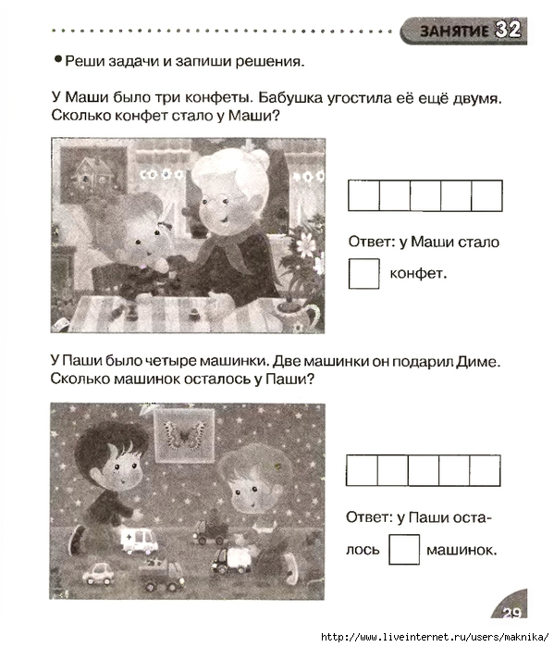](https://img1.liveinternet.ru/images/attach/c/5/89/74/89074143_large_p0030.jpg)  
  
  
[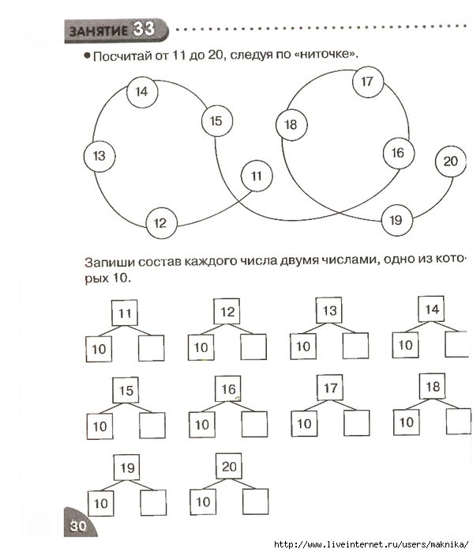](https://img0.liveinternet.ru/images/attach/c/5/89/74/89074144_large_p0031.jpg)  
  
  
[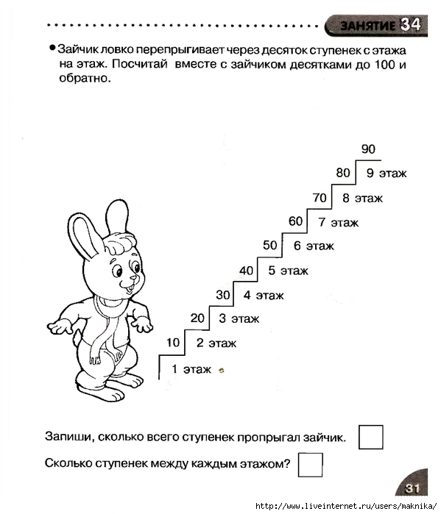](https://img1.liveinternet.ru/images/attach/c/5/89/74/89074145_large_p0032.jpg)  
  
[[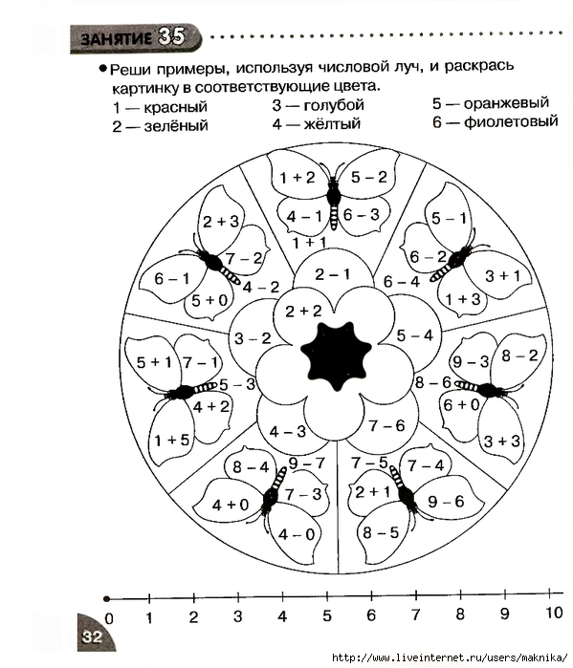](https://img0.liveinternet.ru/images/attach/c/5/89/74/89074146_large_p0033.jpg)](https://img0.liveinternet.ru/images/attach/c/5/89/74/89074146_large_p0033.jpg)